**CS 271 Spring 2020**

**Assignment 7**

**Student ID: 014498887**

**Name: Yash Sahasrabuddhe**

**Q.1.**

1. Calculated the convolution matrix using scipy library. The code is attached with the submission as Q1a.py. The output of the code is as follows: -

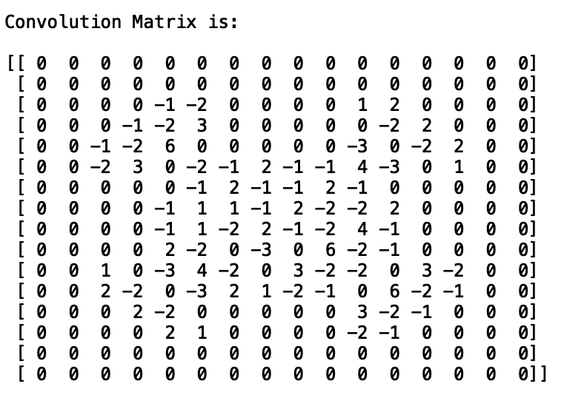

1. Applying the max pooling layer on the respective figure with pool size 4x4, we get a 4x4 pooling layer (considering non-overlapping). The pooling layer is hence calculated by finding the maximum value in the 4x4 sliding array window of the convolution matrix. Finally, we get the following pooling layer matrix: -

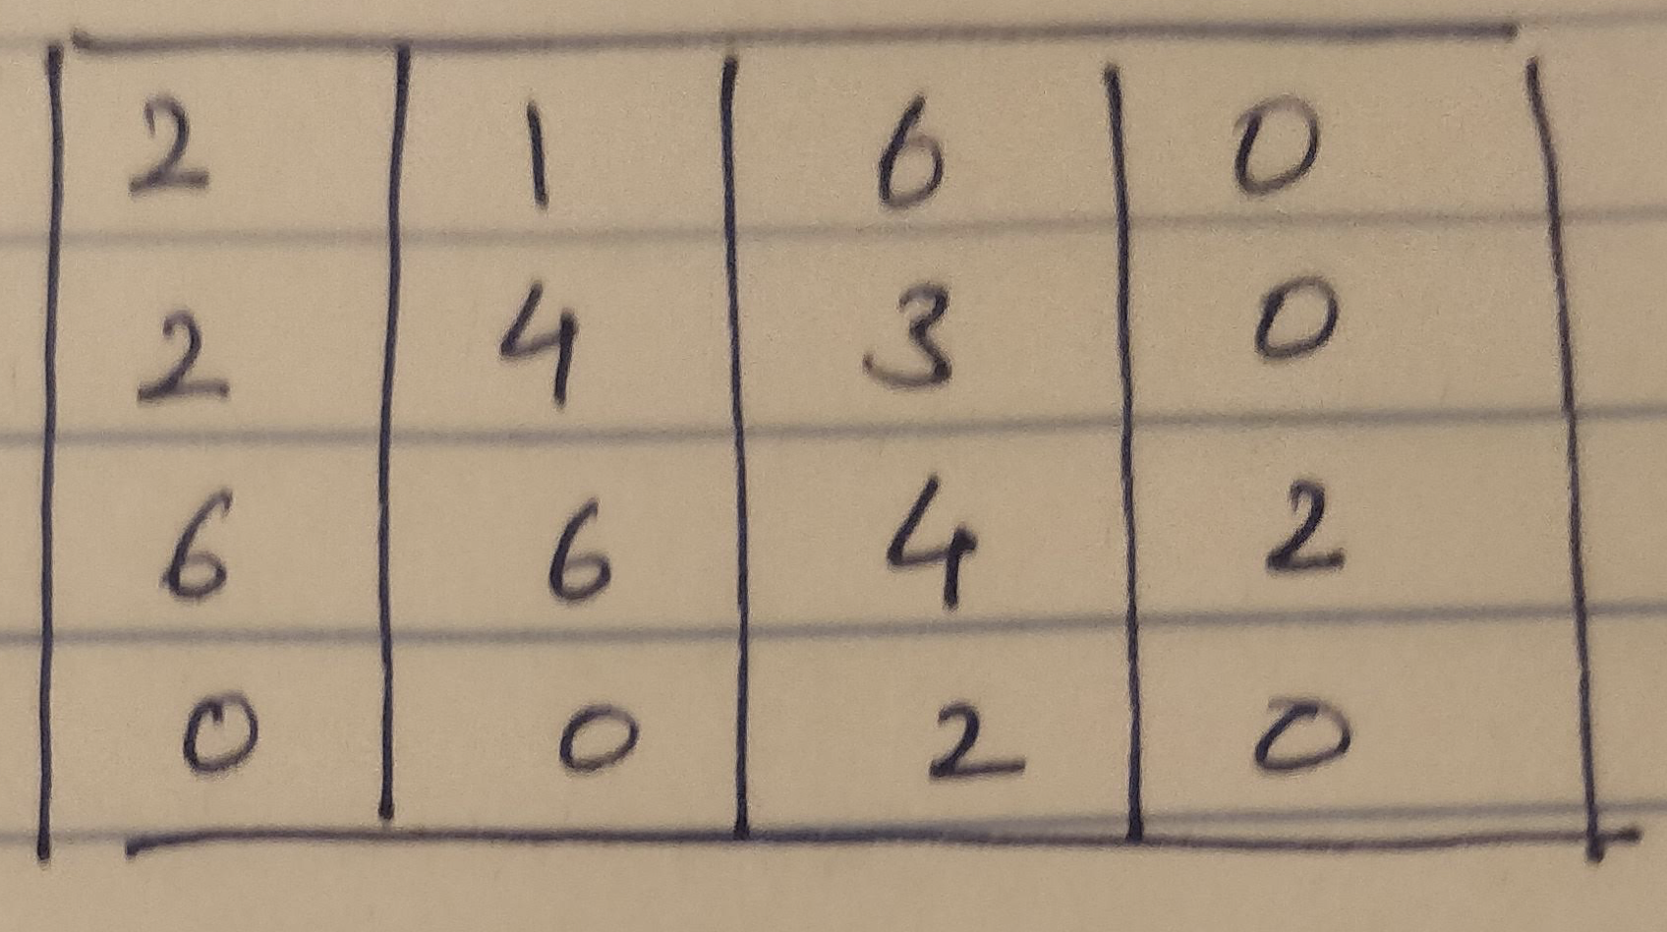

**Q.4.**

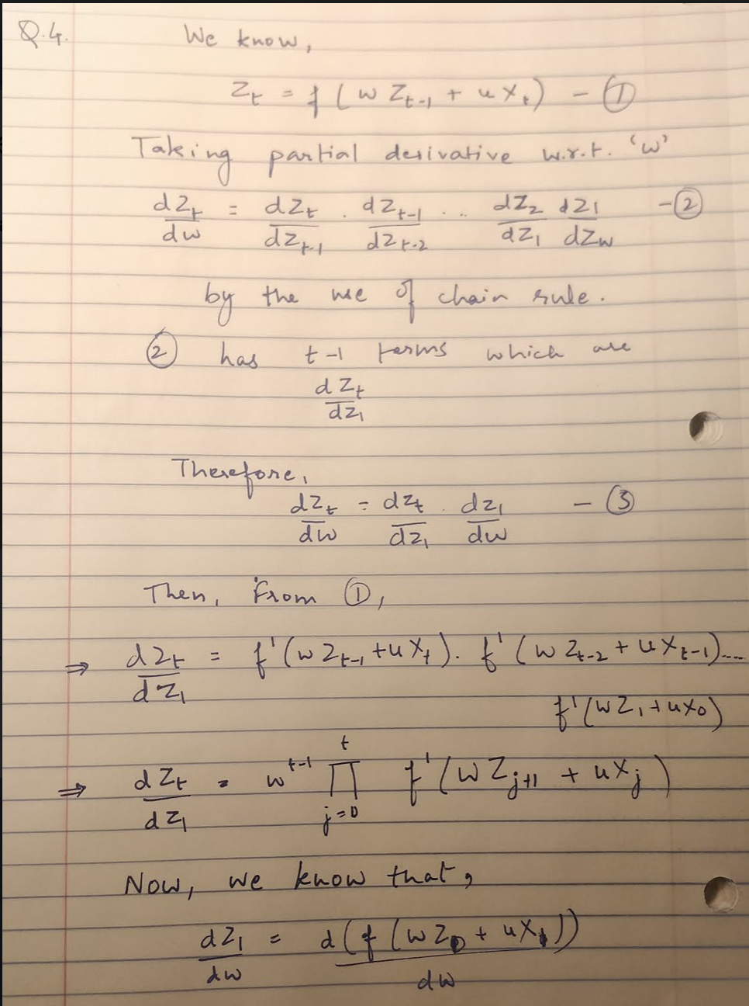

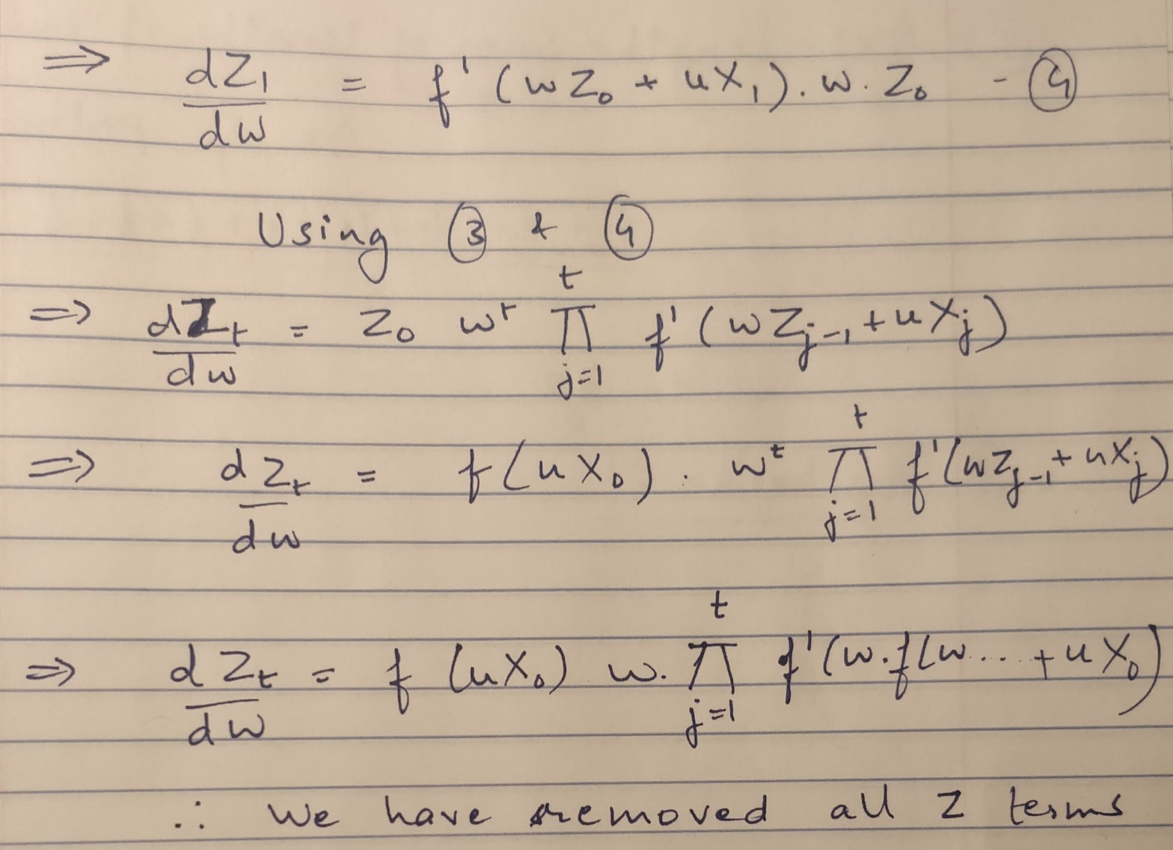

**Q.6.**

1. The (a) part is solved as follows: -

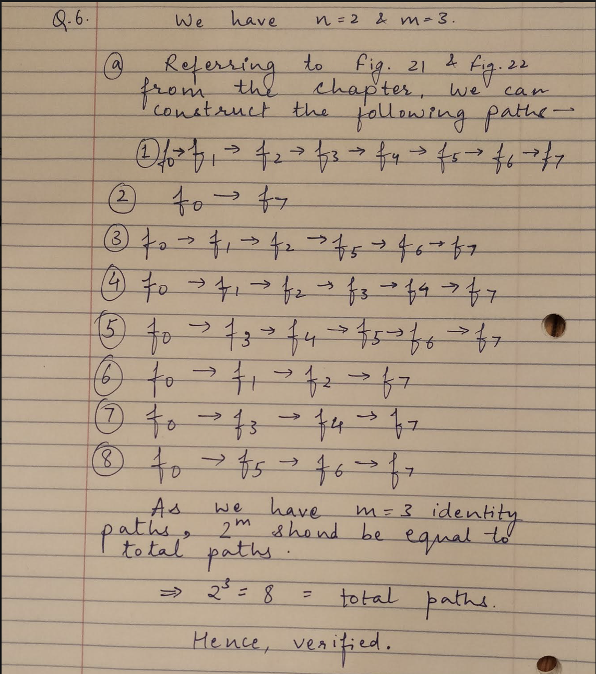

1. The (b) part is solved as follows: -

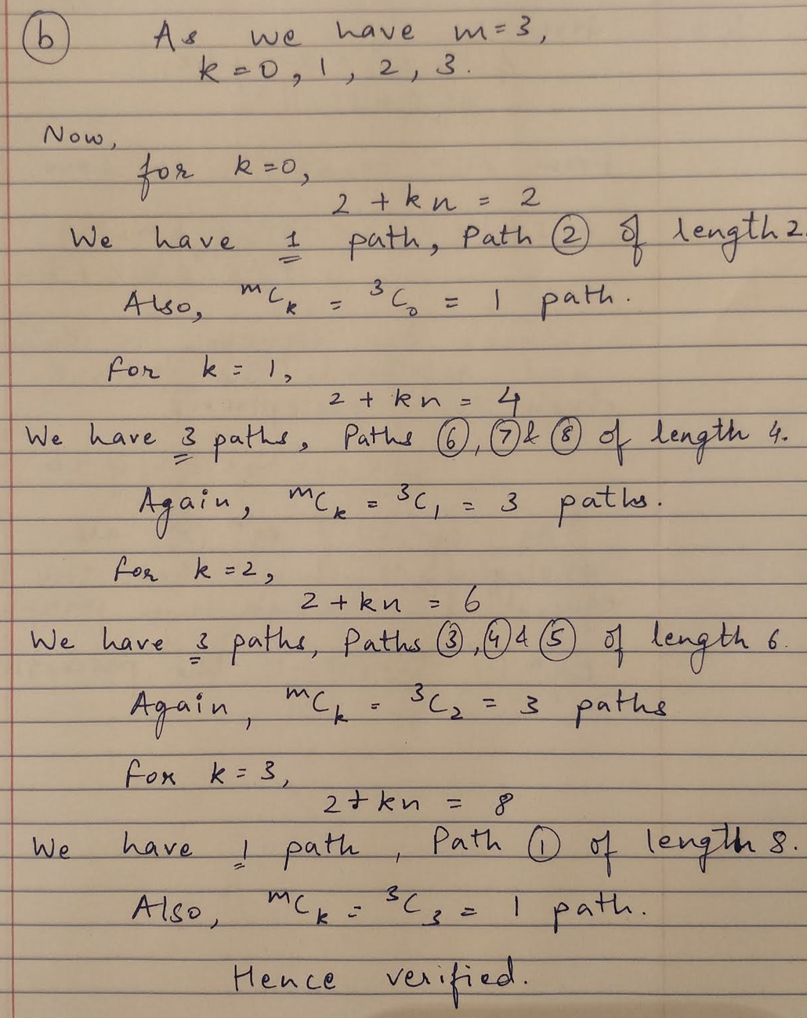

1. The (c) part is solved as follows: -

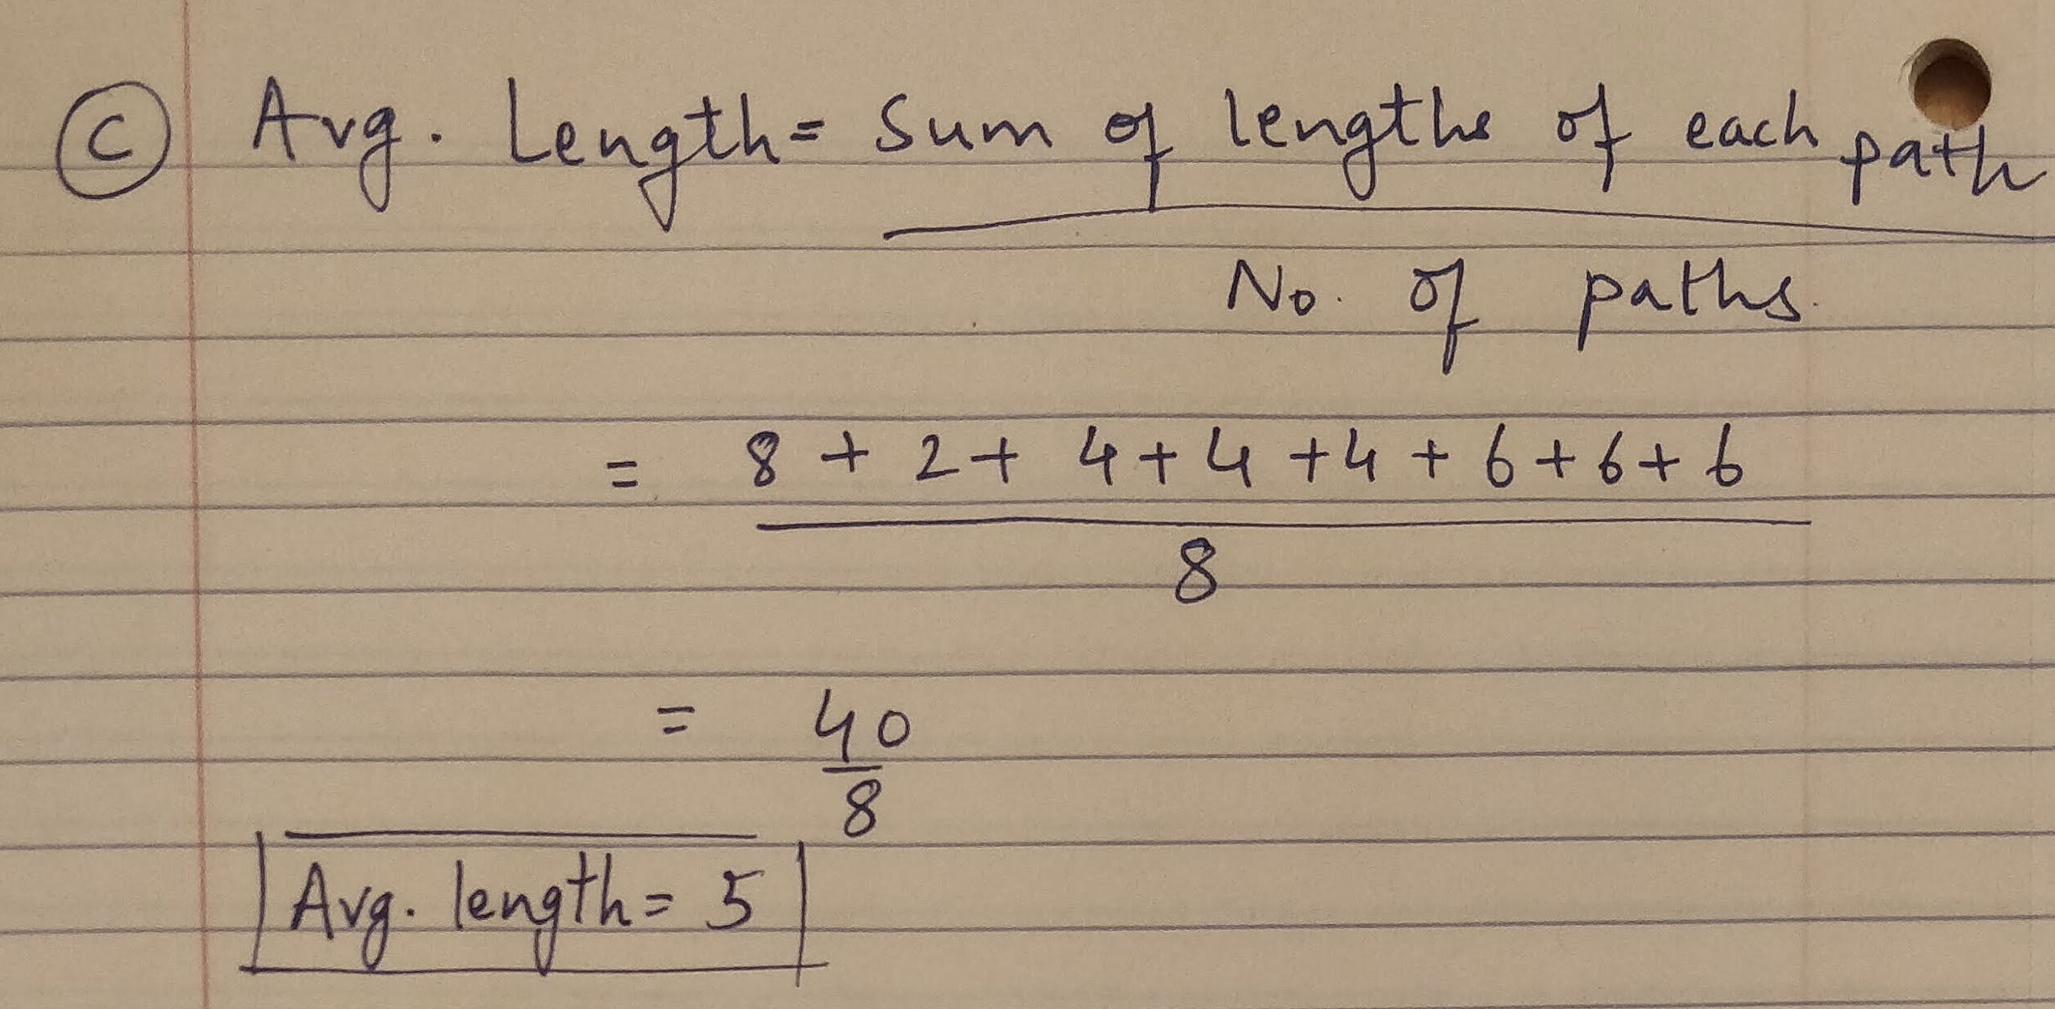

**Q.10.**

1. Using the HMM fast reference code provided by the professor, I computed the cosine similarities between the characters using the method given in the chapter. The computed cosine similarities are stored in an MxM matrix, with the rows and columns representing the alphabets from 0 being ‘a’ till 25 being ‘z’ and 26 considered as ‘space’. Looking at this resultant matrix the following is observed –
2. The cosine similarity value between a character with itself results in 1.
3. The cosine similarity value between a vowel and another vowel is close to 1 showing similarity of characters.
4. The cosine similarity value between a vowel and a character is varying and shows that there is something between these two sets of characters.
5. The cosine similarity value between a character and another character is close to 1 and characters have a similar relation.

**The source code is included with the submission in the folder Q10a along with the output of the code as Q10a Output, which is the terminal output.**

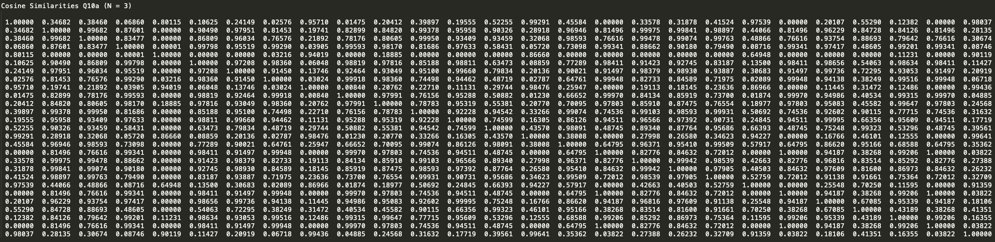The cosine similarities are also given below but is unclear. Hence, separately attached.

1. The same points are observed when executing the code with N = 4, but the closeness of the characters i.e. cosine similarities between a vowel with other vowels and cosine similarities of a character with other characters is comparatively weaker. Having said that, we can still conclude the differences between two sets of alphabets.

**Like part (a), the code for this part is attached with the submission inside the folder Q10b. The output is also attached separately in the folder as Q10b Output, as the values are too many to be clear in this document.**

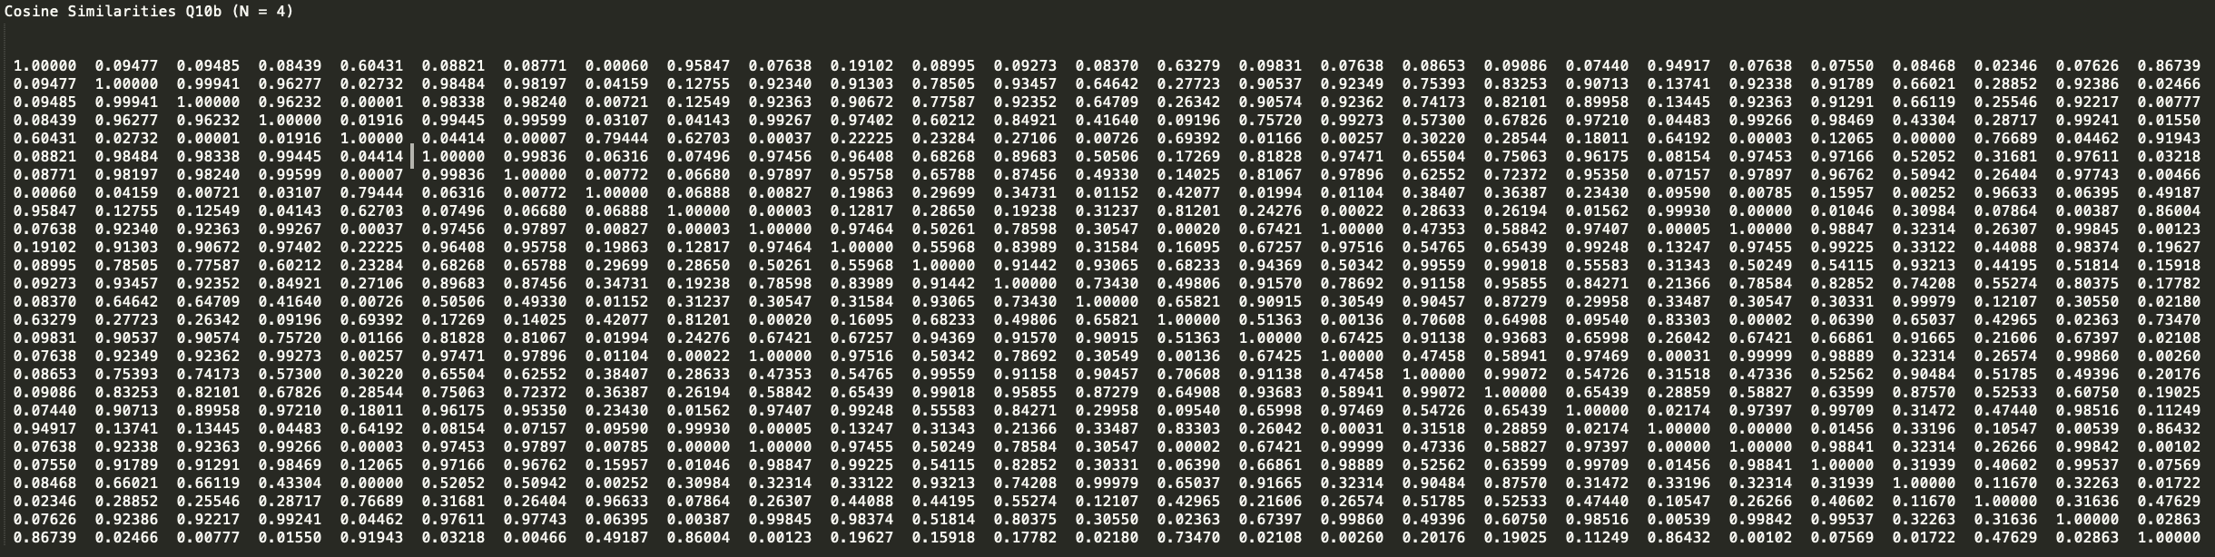In spite of that, I have attached a snapshot of the cosine similarities for this part below-

**Note:-** Discussed with Aditi Walia, Akshay Kajale and Harshit Trehan. No code was shared.